**Root Cause Analysis Techniques**

**#1) Fishbone Analysis**

Fishbone diagram is a visual root cause analysis tool to identify the possible causes of the identified problems and hence it’s also called Cause and Effect diagram. It allows you to get down to the real root cause of the issue rather than solving its symptom.

It’s also called the Ishikawa Diagram as it was created by [Dr.Kaoru Ishikawa](https://en.wikipedia.org/wiki/Kaoru_Ishikawa" \t "_blank)[a Japanese quality control statistician]. It’s also known as Herringbone or Fishikawa diagram.

Fishbone analysis is used in analyze phase of [six sigma’s DMAIC](https://asq.org/quality-resources/dmaic) approach for problem-solving. It’s one of the [7 basic tools of quality control](https://www.softwaretestinghelp.com/quality-tools/)**.**

**Steps to create a Fishbone Diagram:**

Fishbone diagram resembles the skeleton of a fish with the problem forming the head of fish and causes forming the spine and bones of the fish.

**Follow the below steps to create a fishbone diagram:**

1. Write the **problem** at the **head of the fish**.
2. Identify the **category of causes** and write at **end of each bone** [cause category 1, cause category 2 …… cause category N]
3. Identify the **primary causes** under each category and mark it as primary cause 1, primary cause 2, primary cause N.
4. Extend the causes to **secondary, tertiary, and more levels** as applicable.

[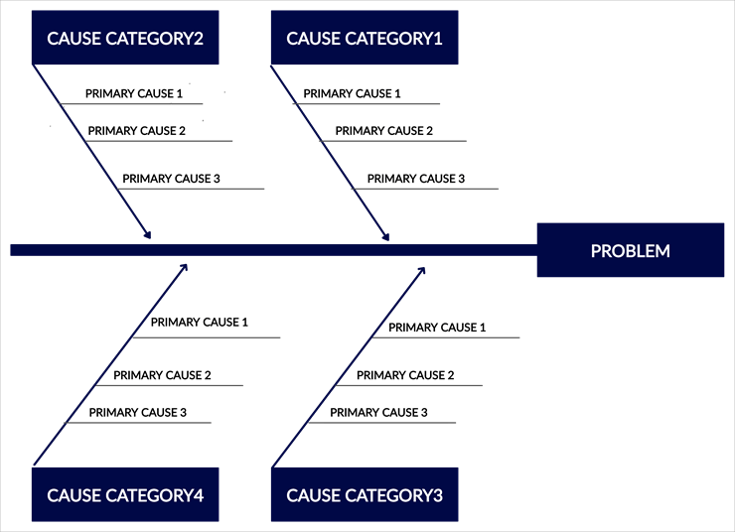](https://www.softwaretestinghelp.com/wp-content/qa/uploads/2020/06/FIshbone_template-1.png)

**An example of how a fishbone diagram is applied to a software defect (see below).**

[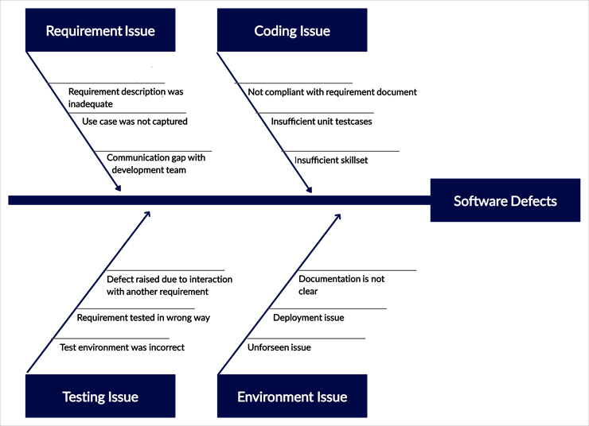](https://www.softwaretestinghelp.com/wp-content/qa/uploads/2020/06/FIshbone_softwareDEfect-1.png)